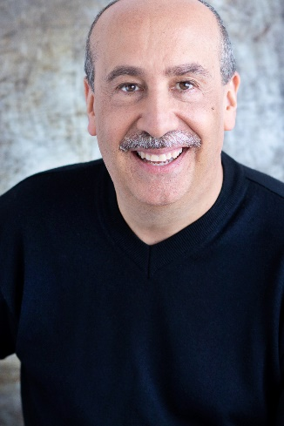
Stats:
Height 6’0” Suit 42R
Weight 186 lbs. Shirt 16.5x32
Eyes Brown Pants 34x32
Hair Balding, Salt & Pepper Shoe 11W

Advertising

Cracker Barrel Big Spoon Industries Boss
NuWave LLC (In House) On Screen Testimonial
Norte Clothing (In House) Basketball Referee
MD Hearing Aids (In House) Father/Grandfather
Get Flooring Clients That Buy On Screen Spokesperson
Ariens Snow Throwers/Radio Tanner Monagle Normal Guy
Build America Mutual Michael Walters Adv. On Screen Spokesperson
Coors Brewing ARC USA/Leo Burnett CEO
Blain’s Farm & Fleet OC Creative Father
Brady Corporation Circle Pictures Football Coach

Corporate/Industrial
Outcome Health Heave Ho Productions Patient
Morrison & Foerster LLP. Sky Pike Productions Lawyer Interviewer
10th MKE Film Festival Laughlin Constable Jukebox Guy
American Academy of Dermatology (In House) Doctor of Dermatology
Siemens Health Molecular Imaging Nels Akerland Photog. Physicist/ Patient
Bigfoot Biomedical ReelPaws Doctor
Dr. Oz/Sharecare.Com (In House) Self
Feeding America Image Base Silhouette Artist
James Hardie Building Products Reflection Media Services Tech Sales Lead

Episodic Television
Chicago Med (3-13) NBC/Universal Peter Lancaster
Streaming Video

The Onion/Clickhole (In House) Combover Man

Training
Vagabond School For The Arts - Improv For Commercials - Michael McCracken instructor

Video Reel – https://castharvblain.video/viewreel

